**TEST PLAN AND OUTPUT**

1. 1)To check for login i.e, username and password.

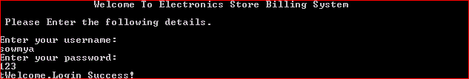

2)If username is wrong then it gives invalid username.

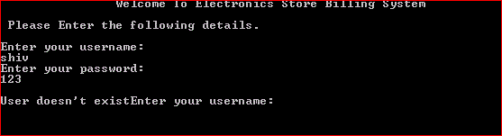

3)If password is wrong then it gives invalid password.

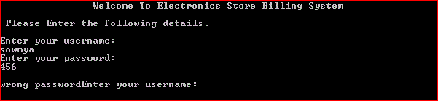

1. Checking the Generation of bill format which includes time and cashier’ name , customer’s nameand phone number ,along with the calculations.

